Dear Families,

Thank you for your support as we navigate the ever-changing pandemic. All staff and Residents have been vaccinated and we are so pleased to be able to return to short, masked, indoor visits so that you can see your loved one face-to-face.

Whitman County is currently in Phase 2 of the State’s restart plan. As such, only compassionate care “intended to permit limited indoor visitation and necessary support to residents facing serious health or emotional crises. These visits are only permitted in ‘end-of-life’ or ‘psychosocial need’ circumstances.” We are focused on meeting the psychosocial needs of our Residents and welcome visits at this time.
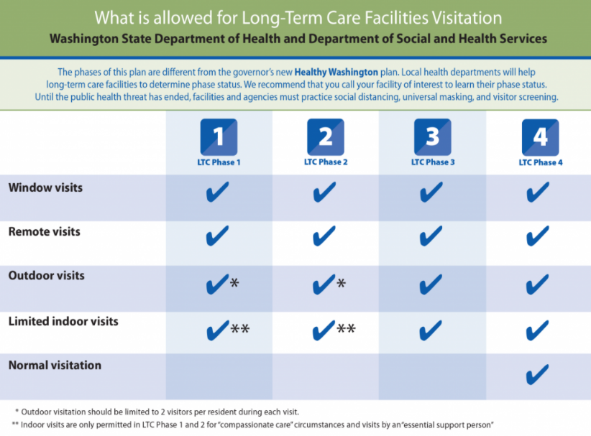

Visits for compassionate care may be undertaken by what the state calls an “essential support person” which can be a family member or caretaker. A visit can involve more than one essential support person but a distance of six feet must be able to be maintained between visitors at all times.

There are no time limits for visits on State documents, but following CDC suggestions about limiting potential exposure, visits of fifteen minutes or less will be our guideline. According to State documents, hugging your loved one is alright so long as masks are left on during the entire visit and the visit is less than fifteen minutes long.

Given that all client rooms are individual rooms, and all have the ability to leave the window/door open slightly while at the same time maintaining the bedroom door to the hallway closed, air circulation can be directed outdoors rather than remaining inside the room or exiting into the rest of the facility.

If essential support persons have been fully vaccinated, a masked longer visit may take place. Under those circumstances, the above requirements for air-circulation would still apply.

For all compassionate care visits, prior notification to the facility is required, unless previous arrangements have already been made on a standing basis. To arrange a visit, please call us at the number provided below.

Feel free to contact us with any questions you may have.

Sincerely,

Rob M. Ndambuki, Owner

